Relational model
- Most spread data model.
- It is very clean and not complex.
- Lot of support and resources online

Relational database: a collection of relations

Relationship ≠ relation
- Relationship: between entities
- Relation (almost the synonyms of table): mathematical object made of two parts:
  - Schema of the relation: contains name of the relation and name and type (int, boolean, string, …) of each column (columns are sometimes called attributes or fields). We are talking about the content of the table
  - Instance of the relation: actual content of the table without the header. Organized in rows and columns.
    - Rows: cardinality
    - Columns: attributes/degree of the relation

Table ≠ relation. In a table you can repeat multiple times the same row, in a relation you can not. In a relation there is not a real order of rows, it is just a collection of elements. In a real world scenario it might happen anyways to have the same row.

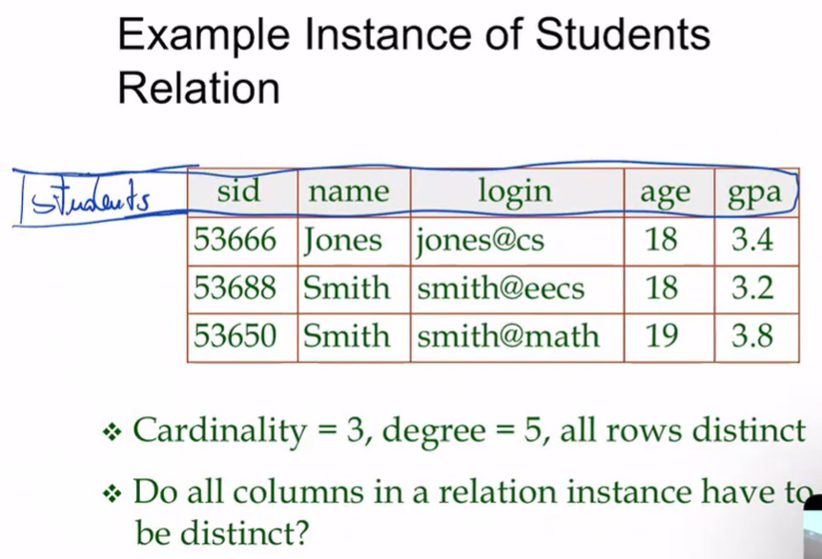

- Schema in blue
- Instance is everything else
- Cardinality is 3 (there are three rows)
- Degree is 5 (there are five columns)
- All rows are distincted

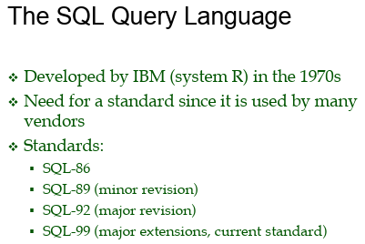

SQL = Structured Query Language

SQL is a very complex language

Divided in 3 sublanguages, each with a certain goal
- DDL: Data Definition Language, specify the relation you want (I want a primary key, constraint relationship). With DDL you do not modify the data, you only define it. You only touch the schema, not the instance (in python is like defining a function or a class)
- DML: Data Manipulation Language. Allows you to interact with some instances (add, remove, update a row, …)
- DQL: Data Query Language. Allows interaction with the database, to query and know something inside the database. Every question you ask is in DQL

PROCESS
You ⟹ Entity relationships diagram ⟹ DDL (define schema) ⟹ DML to fill the database ⟹ DQL query the database

SQL: Data Definition Language (DDL)

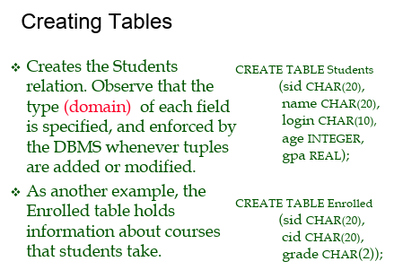
Es: you want the schema of the relation student.
SQL is not case sensitive (convention: usually key word in capital)

CREATE TABLE Students → name of the table
(sid CHAR(20), → open parenthesis and list everything
name CHAR(20),
login CHAR(10),
age INTEGER,
gpa REAL);

separate attributes with a comma and specify the type
- Integer: just a number
- Real: floating number
- Bool: for boolean value
- String
  - Char(20) → attribute of exactly 20 characters. If it is less it is filled with empty space, if more is error
  - Varchar(20) → attribute of 20 characters. If less is ok, if more is error
  - varchar or text → don’t care about the number of characters

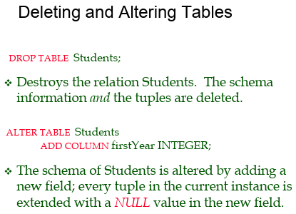

Other commands schema-related

Both the content and the schema information are deleted.

Or you can add a column by specifying the name of the column and the type

NULL in sql means that there is a value but you don’t know what it is. Like you know that each person has a phone number but if someone in the data doesn't have the number you should put NULL because you don’t have it but you don’t know what it is.

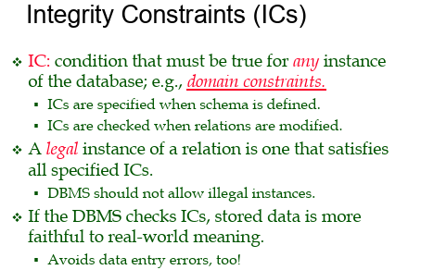

Try to guarantee the integrity of the data. DBMS should not allow illegal instances because they do not represent proper data

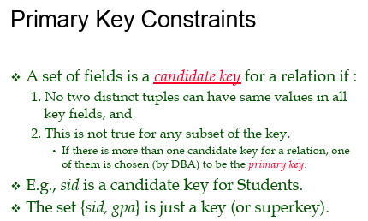
Avoid two rows in the table that are different but the same key. We want also the minimal key

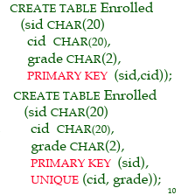
When we create a table called Enrolled with student Id, course id and grade we also can specify that there should be only a mark of a student for each course

We can also specify the primary key (one or more attributes)

There are cases in which you want to enforce the primary key and the codice fiscale.

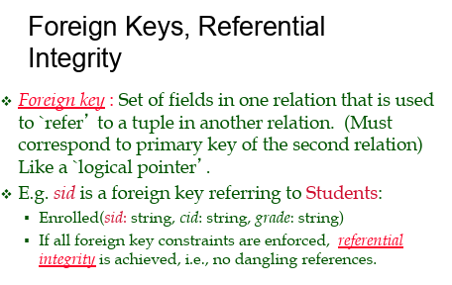
Foreign keys: constraint that you put on a table that explain that one or more attributes of a table should be considered as a key of another table

One constraint in the enrolled table is that we cannot have multiple grades for the same student in the same course.

We must be sure also that the student id must be an identifier

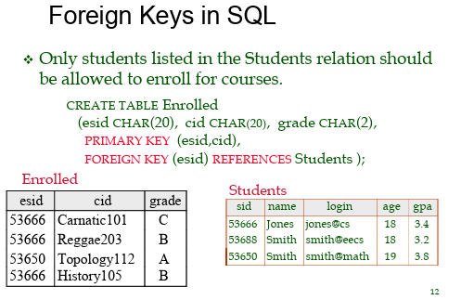
There must be a forging key that connects the student id between students and enrolled.

It is forbidden to have an esid in the enrolled table that does not appear also in the sid of the Students table.

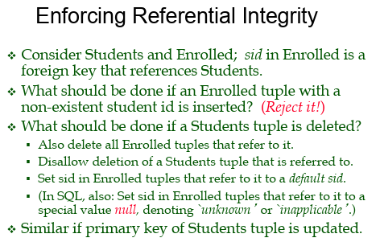

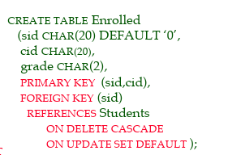
We can specify a default value (must be coherent with the type) it means that every time we add a new row on the table and you don’t have the student id (sid) it will be 0.

For the foreign key we can specify an action when the Students is deleted. If some tuples in the students are removed we should propagate the deletion on the enrolled.

Also we can specify what to do when the primary key of a student is not deleted but updated. If I update the sid in Students we could ask to propagate the change to the Enrolled table (cascade) or set to default.

Or we can specify set null, so that when it is deleted it is set to null.


Which integrity constraint should be use?

All those constraints we choose them in order to represent a real word system.

You can never infer constraint from the data, if I see that all surnames of the students are different it might not be a good primary key, it is not 100% sure, to be sure you need to understand the data.

Data comes later, first understand what the data is about.

